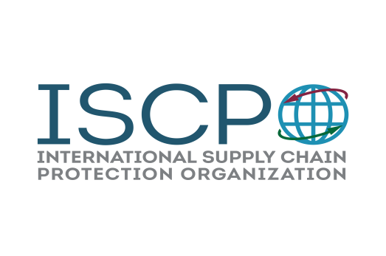

Exhibitor – Sponsor Registration
ISCPO’s 6th Annual Supply Chain Security Summit:

“Global Supply Chain Security Conference”
March 4th- 5th, 2020
7-Eleven Corporate Support Center in Irving, Texas

The International Supply Chain Protection Organization welcomes exhibitor and/or sponsor participation in support of our annual Supply Chain Security Summit. ISCPO is hereby authorized to reserve exhibit space for the company/organization listed below.

(Please print legibly)

DEADLINE: January 31st, 2020

Name of Company/Organization:

____________________________________________________________________________

Name of Authorized Contact:

_____________________________________________________________________________

E-mail (required field): ______________________________________
Mailing Address: ___________________________________________________________________________

_______________________________________________________________________________________________

Telephone: (_______) ______________________
Name, title and email address of representatives attending conference:

1) Name: __________________________________Title: ______________ Email: _________________________

2) Name: __________________________________Title: ______________ Email: _________________________

General Information

Conference Location: 7-Eleven Corporate Support Center
3200 Hackberry Rd
Irving, Texas 75063
- Exhibitor set-up Tuesday afternoon, March 3rd
- Conference is from 8:00am – 5:00pm, March 4th and 8:00am – 1pm on March 5th
- Exhibitors are not required to pay any additional individual registration fee beyond the initial exhibitor fee
- Booth will be limited to a 6X3 table with power/Wi-Fi in the conference area
- Exhibitor and Sponsorship selections/pricing are listed below
- Return completed form to byron.smith@iscpo.org

Special Requests:
□ Special Needs?

An electronic invoice will be generated and sent for payment. If you are required to pay by check, use the address below:

ISCPO 5308 Sutton Circle McKinney, Texas 75070

□ Exhibit Booth $850.00 (Includes up to 2 attendees. $75.00 per additional representative)

Sponsorship Opportunities
□ Breakfast Sponsorship (2 Opportunities) $1,500.00 each
□ Business Break Sponsorship (3 Opportunities) $850.00 each
□ Lunch Sponsorship (1 Opportunity) $2,500.00
□ Cocktail Hour Event Sponsorship (1 Opportunity) $3,700.00

